Samsung Galaxy A7 Lite Restart Methods

Restarting your Galaxy Tab A7 Lite can help if you experience continuous resetting / rebooting, crashing, freezing or if the touchscreen is unresponsive.
- Since this device has a non-removable battery, the restart (soft reset) process can be used to simulate a 'battery pull' when the device is unresponsive, frozen or doesn't power on.
- In rare cases, a restart could affect data (e.g., backup in progress, cached data, etc.).

Preferred Method

- Press and hold the Volume Down button and the Power / Side button (upper-left edge when held in landscape) until the 'Power off' prompt appears on the screen then release.
If the device is unresponsive, attempt the alternate method.
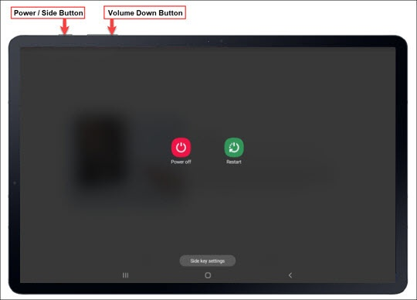
- Tap Restart.
- To confirm, tap Restart.
If your device won't power back on, partially charge the device then retry.

Alternate Method
- Simultaneously press and hold the Volume Down button and the Power / Side button (upper-left edge when held in landscape) until the screen goes black (approx. 15 seconds) then release.
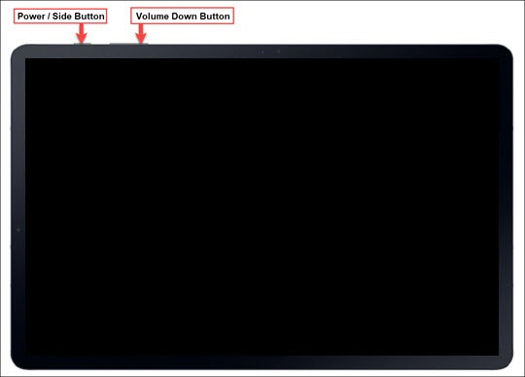
- Allow several seconds for the reboot process to complete.
If your device won't power back on, partially charge the device then retry.

