How to Send eFax using Faxage
Email: helpdesk@americareny.com
Helpdesk (855) 227-3797
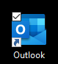
- Open Outlook

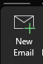
- Click on New Email

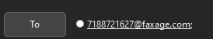
- Enter Faxnumber@Faxage.com (ex. 7188721627@faxage.com)

- Attach the file you would like to send. Please make sure that all documents are PDF.

- If you would like to include a Fax Cover message, please put it in Subject Line

Preview
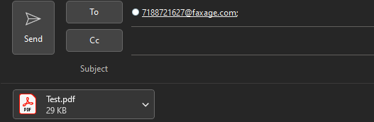

Email Confirmation Preview and e-Fax Outlook Rules

Email Confirmation Preview
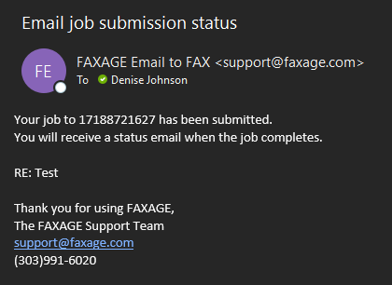

How to add an eFax Rule to your Outlook please see our knowledge base Article.
https://theamericare.zendesk.com/knowledge/editor/01HETCS3RJ1N48FD83SBDZVKAG/en-us?brand_id=13089678180375

If you have any questions kindly contact the Helpdesk.

